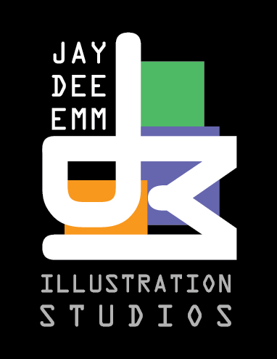
Joshua Martin
845-796-6541
www.jdmillustration.com
jdmillustration@gmail.com

SKILLS:

COMPUTER TRADITIONAL Corel Painter Pen and Ink Adobe Illustrator Graphite Pencils Adobe Photoshop Colored Pencils
Adobe Flash Charcoal
Adobe Dreamweaver Oil Painting

EDUCATION:

The Art Institute of Fort Lauderdale Fort Lauderdale, FL Bachelor of Science Degree in Illustration June 2016

Sullivan County Community College Loch Sheldrake, NY Associate of Science Degree in Computer Graphics May 2013

HONORS:

Honor Roll September 2013 – June 2016

EMPLOYMENT:

JDM Illustration Studios May 2016 – Current

